Project Title: "Understanding OSI Layers through Protocol Analysis"

Objective:

To explore the OSI model layers through practical analysis of protocols and their interactions.

Materials Needed:

- Computer with internet access

- Packet sniffing software (e.g., Wireshark)

- Sample network traffic (optional)

Project Outline:

1. Introduction (5 minutes)

- Briefly introduce the OSI model and its seven layers.

7 layers :  
 1. Physical: physical cable

2. Data Link Layer : packets into frames and sends them from source to destination

3. Network Layer: Break up into network packets and also reassembling them into orderthe

4. Transportation Layer : Breaks into segments

5. Session Layer : Maintains the open sessions

6. Presentation Layer : Prepares data for the application layer

7. Application Layer: Human and computer interact

- Explain the importance of understanding these layers in network communication.

2. Layer-by-Layer Analysis (30 minutes)

Layer 1: Physical Layer

- Discuss the physical components of network communication (e.g., cables, connectors).

* Cables: Copper, fiber-optic, or wireless radio waves
* Connectors: RJ-45 for Ethernet cables, Fiber ST and SC for fiber cables, and Fiber LC for fiber optic cables

- Demonstrate how physical layer issues can affect communication.

The first problem is that electrical transmission can be affected by electromagnetic interference. Interference can have various sources including natural phenomena (like thunderstorms, variations of the magnetic field,…) but also other electrical signals (such as interference from neighboring cables, interference from neighboring antennas,…). Due to these various types of interference, there is unfortunately no guarantee that when a host transmit one bit on a wire, the same bit is received at the other end. This is illustrated in the figure below where a DATA.REQUEST(0) on the left host leads to a DATA.INDICATION(1) on the right host.

Layer 2: Data Link Layer

- Explore data link protocols such as Ethernet (802.3) or Wi-Fi (802.11).

**Ethernet (IEEE 802.3)**

**Ethernet** is a widely used wired network technology that follows the IEEE 802.3 standard. It defines the physical layer and data link layer's media access control (MAC) protocol. Ethernet frames are used to encapsulate data sent over the network.

**Key Characteristics:**

* Operates at Layer 2 (Data Link Layer) of the OSI model.
* Uses MAC addresses to identify devices on the network.
* Supports various physical media like twisted-pair cables, coaxial cables, and fiber optics.

**Wi-Fi (IEEE 802.11)**

**Wi-Fi** is a wireless networking technology based on the IEEE 802.11 standards. It allows devices to connect to a local area network (LAN) using wireless communication.

**Key Characteristics:**

* Operates at Layer 2 (Data Link Layer) of the OSI model.
* Uses radio waves to transmit data over short distances.
* Supports various frequency bands, primarily 2.4 GHz and 5 GHz

- Capture and analyze Ethernet frames or Wi-Fi packets using Wireshark.

- Discuss MAC addresses and frame structure.

**MAC Addresses:**

* **MAC Address** (Media Access Control address) is a unique identifier assigned to network interfaces for communications at the data link layer.
* A MAC address is 48 bits (6 bytes) long and typically represented in hexadecimal format, e.g., 00:1A:2B:3C:4D:5E.

Layer 3: Network Layer

- Investigate network layer protocols like IP (Internet Protocol).

- Analyze IP packets to understand addressing (IPv4 or IPv6).

- Discuss routing and packet forwarding.

**IP** is a fundamental network layer protocol in the Internet Protocol Suite. It is responsible for delivering packets from the source host to the destination host based on their addresses. IP provides a connectionless and best-effort delivery service, meaning it does not guarantee delivery, order, or error correction.

**Key Characteristics:**

* **Connectionless:** Each packet (datagram) is treated independently.
* **Best-effort delivery:** No guarantees for delivery, order, or error checking.
* **Addressing:** Uses IP addresses to identify source and destination hosts.
* **Routing:** Determines the path packets take through the network.

**Routing:**

* **Routing** is the process of determining the path that packets take from the source to the destination.
* Routers use routing tables and protocols (e.g., OSPF, BGP) to decide the best path for packet forwarding.
* **Static Routing:** Manually configured routes.
* **Dynamic Routing:** Automatically adjusted routes based on current network conditions.

**Packet Forwarding:**

* **Packet forwarding** is the process of moving packets from the input interface to the appropriate output interface based on the routing table.
* Each router examines the destination IP address in the packet header, looks up the routing table, and forwards the packet to the next hop on the path to the destination.

Layer 4: Transport Layer

- Examine transport layer protocols such as TCP (Transmission Control Protocol) or UDP (User Datagram Protocol).

- Discuss port numbers and reliable vs unreliable delivery.

**Reliable Delivery (TCP):**

* TCP provides reliable delivery by using sequence numbers, acknowledgments (ACKs), and retransmissions.
* Each byte of data is numbered, and the receiver acknowledges the successful receipt of data.
* If data is lost or corrupted, TCP retransmits the data.
* Ensures data integrity and correct order of delivery.

**Unreliable Delivery (UDP):**

* UDP does not guarantee delivery, order, or error checking.
* Data may be lost, duplicated, or delivered out of order.
* Suitable for applications where speed is more critical than reliability (e.g., live video or audio streaming).

- Capture and analyze TCP/UDP segments.

Layers 5-7: Session, Presentation, and Application Layers

- Provide brief overviews of session, presentation, and application layers.

The presentation layer takes any data transmitted by the application layer and prepares it for transmission over the session layer. The session layer creates communication channels, called sessions, between devices.

- Discuss protocols like HTTP, FTP, SMTP, and their roles in communication.

**FTP:**

FTP works on a client-server model. The FTP client is a program that runs on the user’s computer to enable the user to talk to and get files from remote computers. It is a set of commands that establishes the connection between two hosts, helps to transfer the files, and then closes the connection. Some of the commands are: *get filename(retrieve the file from server), mget filename(retrieve multiple files from*the *server ), ls(lists files available in the current directory of the server).*

**SMTP:**  Simple Mail Transfer mechanism (SMTP) is a mechanism for exchanging email messages between servers. It is an essential component of the email communication process and operates at the application layer of the TCP/IP protocol stack. SMTP is a protocol for transmitting and receiving email messages. The SMTP server is an always-on listening mode. As soon as it listens for a TCP connection from any client, the SMTP process initiates a connection through port 25. After successfully establishing a TCP connection the client process sends the mail instantly. 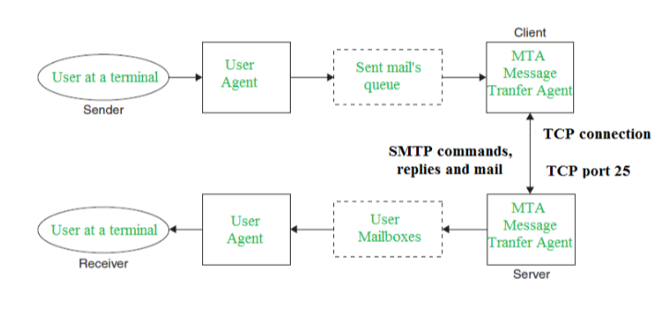

- Examine application-layer data and headers.

3. Conclusion and Discussion (20 minutes)

- Summarize the findings from the protocol analysis.

 – Layers 4–7 (host layers) provide accurate data delivery between computers

   – Layers 1–3 (media layers) control physical delivery of data over the network